# Styles

The style suggestions section of BMMX can take various styles. Here are all the styles you can use, formatted as “name (comment) - name in code”:

* BTS (requires BTS UCP or old BEE2, before BTS was removed) - BTS
* Clean - Clean
* Original Clean - Clean_original
* Grass Clean (requires UCP by joethegamer) - Clean_grass
* Overgrown - Overgrown
* Portal 1 - P1
* Grey developer style (requires Drgregs’ Dumb Styles) - Devstyle_grey
* Light grey dev. style (requires Drgregs’ Dumb Styles) - Devstyle_lightgrey
* Orange dev. style (requires Drgregs’ Dumb Styles) - Devstyle_orange
* Original grey&orange dev. style (requires Drgregs’ Dumb Styles) - Devstyle
* Reflective light grey dev. style (requires Drgregs’ Dumb Styles) - Devstyle_reflective
* Garry’s Mod Style (requires Drgregs’ Dumb Styles) - Gmod
* Rattman style (requires Drgregs’ Dumb Styles) - Rattman
* 1950s Old Aperture - OldAperture_50s
* 1960s Old Aperture - OldAperture_60s
* 1970s Old Aperture - OldAperture_70s
* 1980s Old Aperture - OldAperture_80s

# Critical runtime exception: list contains “

If you get this error, this means one of your lists contains “ (or \”, the only way to do it in code). Please remove this character from all of your lists. If your lists do not have it, please contact me: electrovoyage.#9148 on Discord.

# Package creation guide

If the text instructions logged after the end of package generation are unclear, here is a step-by-step guide:

* Step 1. Copy the entirety of the script’s log from the beginning up until “//Compile sequence ended” and paste it into a text file called “info.txt”.

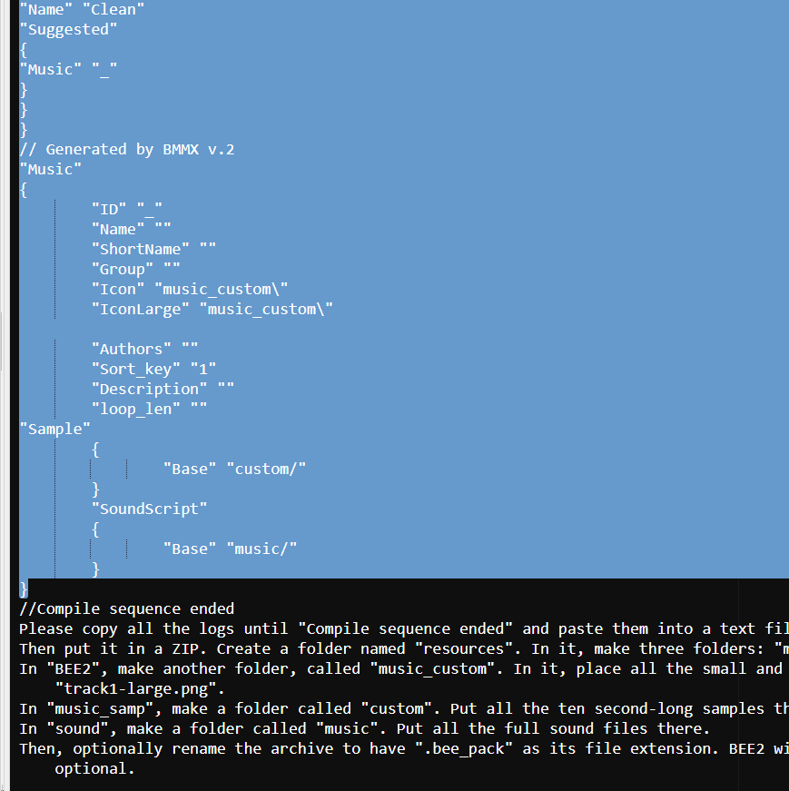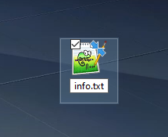

* Step 2. Create a ZIP archive and make three folders in it: **BEE2**, **music_samp** and **sound**. After this, your archive should look like this:

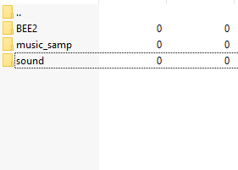

* Step 3. Place your **info.txt** in this archive. Do not place it in any of these folders.
* Step 4. In BEE2, make a folder called **music_custom**.
* Step 5. In music_samp, make a folder called **custom**.
* Step 6. In sound, make a folder called **music**.
* Step 7.1. In music_custom, put all the images. .PNG is advised.
* Step 7.2. In custom, put all the ten second-long audio samples. You can use .OGG or .WAV.

If your samples are >10 seconds, you can use Audacity or Cloudconvert.

Instructions for Cloudconvert

1. Go to cloudconvert.com and upload your files.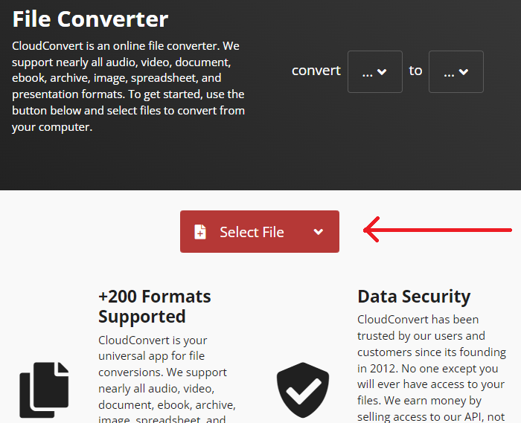
2. When done, select WAV to WAV and click the wrench.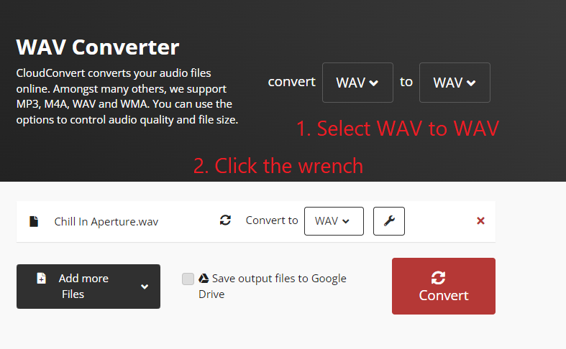
3. Set **Trim Start** to **00:00:00** and **Trim End** to **00:00:10**.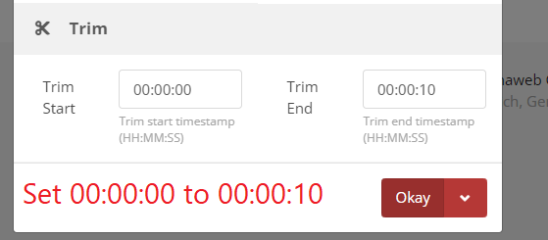
4. Click Okay.
5. Click on Convert and wait until it is done. Then download the files.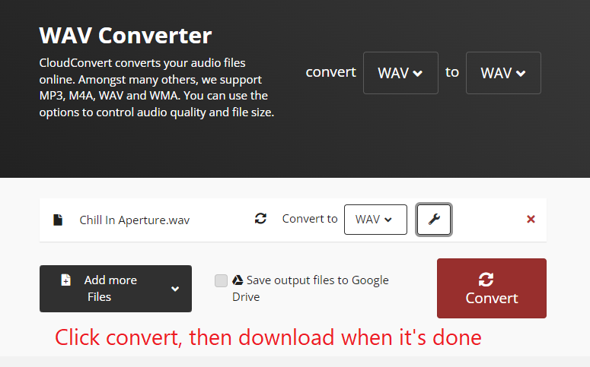

Instructions for Audacity

1. Open your audio in Audacity.
2. At the bottom of the window, set the dropdown to “Start and end of selection”.
3. In the right field, set 00:00:00:00.10: (please excuse me for Russian image)
4. Now press **Ctrl+T** or click this button: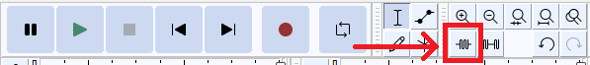
5. Go to **File**>**Export**>**Export as .wav.**
6. Export it however and wherever you like.

* Step 7.3. In music, put all the full audio files.
* Step 7.3.1. If your music is NOT .wav, 44100 hertz, stereo, signed 16-bit PCM, use **Cloudconvert.com** to change this data.
* Step 8. Place this package in your BEE2 **packages/** folder.

Now run BEE2. If anything goes wrong, please contact me and i will help you resolve the issue. If i am unavailable, please tell me in **#bmmx-support** on my server: <https://discord.gg/gb7cp6asJF>. I will read your issues as soon as possible!

# Code parameters

Formatted as **parameter** *type* - detailed description.

**TrackIDPrefix** *string* - the prefix of all track IDs. It works like this: *prefix*_*SongID*

**Tracks** *{string}* - song IDs.

**TrackLen** *{string}* - song lengths. If the amount of minutes is a single digit (including 0), formatted as ***m:ss***. Otherwise should be formatted as ***mm:ss***.

**TrackImgSmall** *{string}* - all filenames of the small square images. Including extension, excluding path.

**TrackImgLarge** *{string}* - all filenames of the large 4:3 images. Same rules as the small images.

**TrackDescs** *{string}* - all track descriptions.

**TrackNames** *{string}* - all full (>3 chars) track names.

**TrackSmallNames** *{string}* - the short names (<20 characters) of the tracks.

**TrackAuthors** *{string}* - track authors. For middle names/nicknames, use the ‘ symbol instead of “ which causes errors. Adding a comma will, in BEE2, change “Author:” to “Authors:”.

**TrackFiles** *{string}* - full track filenames, not including the path but including the extension.

**TrackSamples** *{string}* - 10s sample filenames. The same rules apply here.

**TrackStyleSuggestion** *string* - the suggested style. Refer to the **Styles** section of this document to find out about the valid styles.

**suggestionsEnabled** *boolean* - Self-explanatory. Set to true to enable styled suggestions. You can alternatively set **TrackStyleSuggestion** to *nil* to disable suggestions..

**Group** *string* - the group of your music.

**PackageID** *string* - software ID of the package. Not visible in the GUI unless Developer mode is enabled.

**PackageName** *string* - GUI package name. Only visible in package settings.

**PackageDesc** *string* - GUI package description. Only visible in package settings.

**generateNewPackage** *boolean* - set to true to generate a complete info.txt, set to false to generate only a section of it. Useful for adding tracks to different group, but via a single package.

**onlyGenerateSuggestions** *boolean* - set to true to only generate new suggestions. Useful for your tracks to be suggested in several different styles.